# IntroduCTION

The following note is the manual of use for the PIC2FILE application. PIC2FILE is written in python languages throught the module CV2 permit to convert and image graph in data points exported in cvs format that can be then opened with excel or uploaded in other programs.

# MANUAL

The application is based on a print screen window where we manually are going to pic the points of interest, that will be then digitalized. In order to scale the point we will first select the origin and x,y axis point, successively we are going to select the point in the graph and save them in an exported file. The program step are 4:

1. Fill the information form.
2. Open the image graph you are willing to digitalize and make a print screen.
3. Crop the image.
4. Pic the point on the graph
5. Print plot the graph and create the file
6. Reset the application to start a new work

We can at this point restart from point 0) or if we want to digitalize another line in the same graph as before we can start from point 3).

## Phase 0 insert data

In this phase you need to open the program, this can be done by copying the pic2file folder from the following link:

F:\fpe\Pic2File

The navigate inside the folder:

Pic2File

Inside the folder click on the file main.exe to open the program.

Now you can open your image, do it in such a way to keep you image window not full screen in order to still be able to use the console of the program:

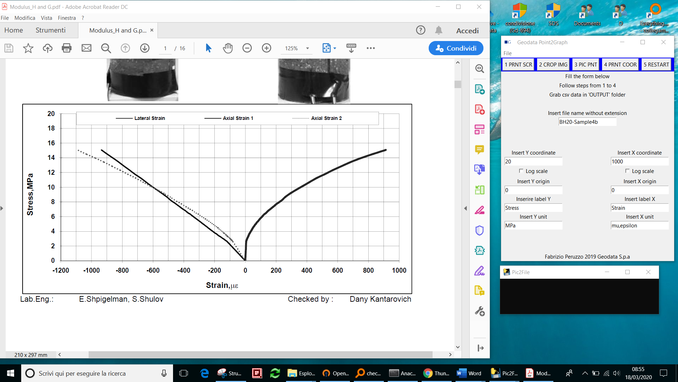

1. Do not open your file in full screen mode
2. Make sure your can see the full graph including the axis scale and labels
3. Fill the form:
   1. Insert the name of the project (important when digitalizing more than 1 graph make sure to change the name otherwise the previous work will be overwritten).
   2. Insert the maximum visible Y coordinate and the maximum X coordinates: in this case is 20, and 1000 (note you can choose either maximum positive or maximum negative).
   3. Insert the origin of the axis (if visible the origin is 0,0 but not all graph are plotted such that the origin is visible, you can therefore for those cases specify an arbitrary origin) in this case Y=0, and X=0.
   4. Insert labels and units of axis

## Make a print of the screen – Push button 1 PRNT – SCR

With this operation you make a copy of everything is in your screen make sure the graph is fully displayed with all information you want to collect, the you are ready to push the button:

**1 PRNT-SCR**

## Crop image

Once you have done so you need to close your pic image or pdf, in order to avoid confusion.

Now push:

**2 CROP IMG**

The picture of your print screen is now open, to crop the relevant part of the graph:

1. Left click on the righ upeer corner
2. Keeping the right mous button down move on the lower left corner of the part you want to crop
3. Release the left button of the mous

Note: this is the common operation you do when you want to select something with a window, however in this program you want be able to see the rectangle of cropping.



1. Mouse Right click 2) keep the button down 3) release the left button

After releasing the left button the window of the graph will close.

## Pic point

You are now ready to begin to pick the point. Click on the button

**3 PIC PNT**

This will open again the graph but with only the cropped part.

In order select:

1. The origin
2. The maximum Y axis or the point you indicated as max in the main form (step 0))

Remember the maximum can even be the negative maximum the only thing to follow is that you need to select the same point you indicated in the form as maximum Y.

1. The maximum X axis or the point you indicated as max in the main form (step 0))

Remember the maximum can even be the negative maximum the only thing to follow is that you need to select the same point you indicated in the form as maximum Y.

1. Now select all point of your graph: you can select only one line of the graph (a line of the same family at time).
2. Press “ESC” on the keyboard twice to close the window.

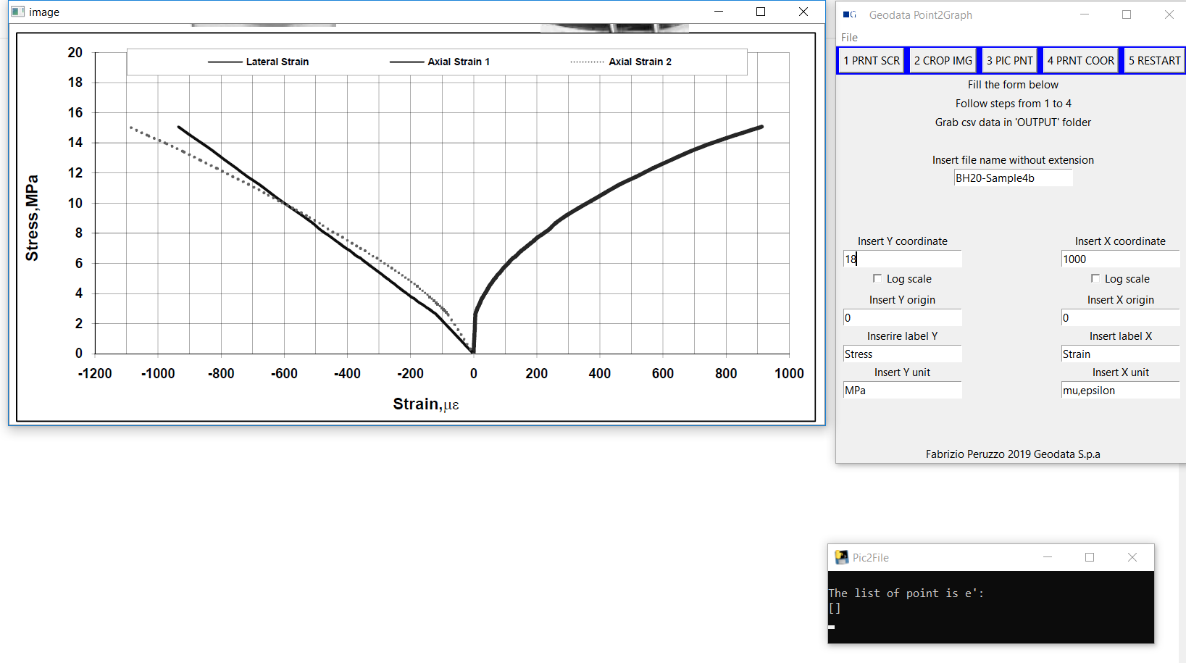

2) click on X max

2) click on Y max if not visible like this case use a different point like 18 instead of 20, just make sure is the same as indicated the form

1) click on the origin

In this case the Y max point (along the vertical axis X=0) is not visible so you need to choose another number as maximum use 18 then, make sure in your form 18 is selected as maximum.

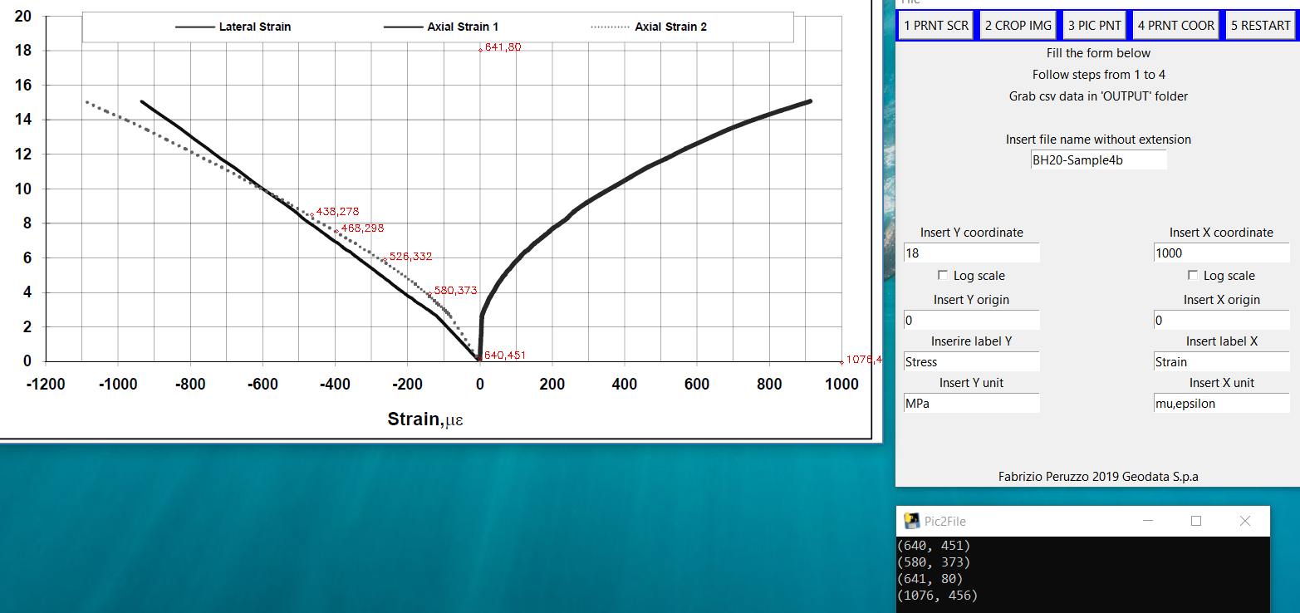

When selecting the point local coordinate will appear

**Note in phase 3 you will not be able to interact with the main form so if you want to change something you need to press 2 time “esc” in the keyboard, the graph will close, you are now able to modify the entries on the form and then push again button 3 PIC PNT to open again the graph.**

**If you choose by mistake a wrong point you can delete it by clicking the right button of the mouse. Note only the last point can be deleted. If you notice that there are other points that are wrongly selected you need to click the right button of the mouse twice: a window will appear to ask you if you want to restart: select yes and restart from selecting the origin.**

## Save file and plot output

You can now save your file, before to press button 4 make sure the name of your file is unique otherwise will overwrite any existing file with the same name (note the name do not have to include the extension). You are now ready to push:

**4 PRNT COOR**

By pressing this button, the digitalized graph will be displayed for you to check if everything is as expected and the file will be saved in the folder:

\Pic2File\Output

The file will have the same name indicated in the form (step 0) and with csv extension. It can now be opened with excel.

## Terminate and start a new job

Your work is finished now, if you wish to restart a new job you need to clear the cache by pushing:

**5 RESTART**

**Now you can either restart from phase 0 or if you want to pic a second line on the same picture as before (remember only one line per instance can be selected) you can presse button 3.**

## Pic point from the same graph

After pushing restart push the button:

**3 PIC PNT**

You are now ready to select another line of the same graph.



3° line job 3 line job1

2° line job 2 line job1

1° line job 1 line job1

**Note each job must have a unique name otherwise the output file will be overwritten.**

## Close the program

When all the graph you need have been digitalized select the window menu “File” and the “exit”.

